Discussion 1: Manifest Destiny
Why did the Mexican War of 1846 take place? Was the war necessary? Was it a good thing? What does this war tell us about this period of American history? Was it God’s plan that the U.S. extend from the Atlantic to the Pacific, or were imperialists looking for a way to defend what they planned to do anyway? Elaborate.
You may already be familiar with this idea, but before we discuss it, make sure that you review our text's discussion of it in Chapter 11, beginning on p. 318.
The events and ideologies that comprise this era are complex, yet the overarching idea of "Manifest Destiny" does an excellent job summing up the "zeitgeist" (literally, "time spirit) of this important piece of the American past. So, to start our discussion, let's take a closer look at two famous paintings that exhibit what someone living in the mid-19th century might have felt about this now controversial idea.
Picture A & B offer similar scenes and settings, but I would argue that both are incredibly useful for what they portray and what they do not portray about this period. After reviewing your text and these images, what strikes you? What do the images say about this idea? What do they not say? What are they highlighting? What are they ignoring?
A.
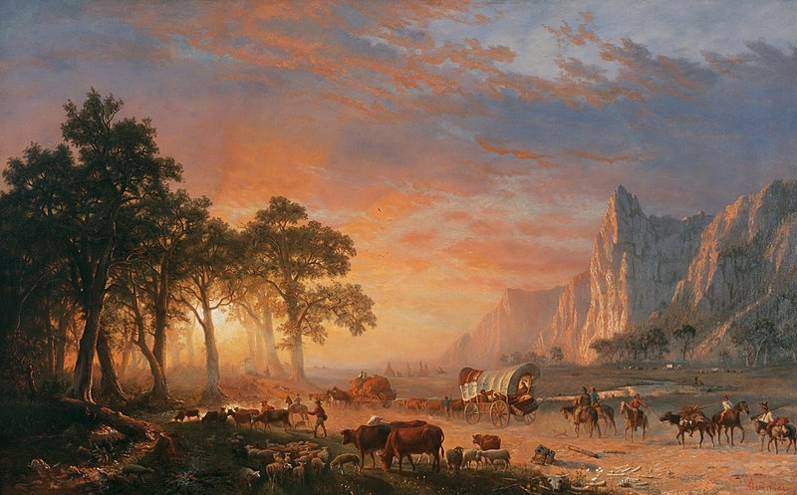

B.
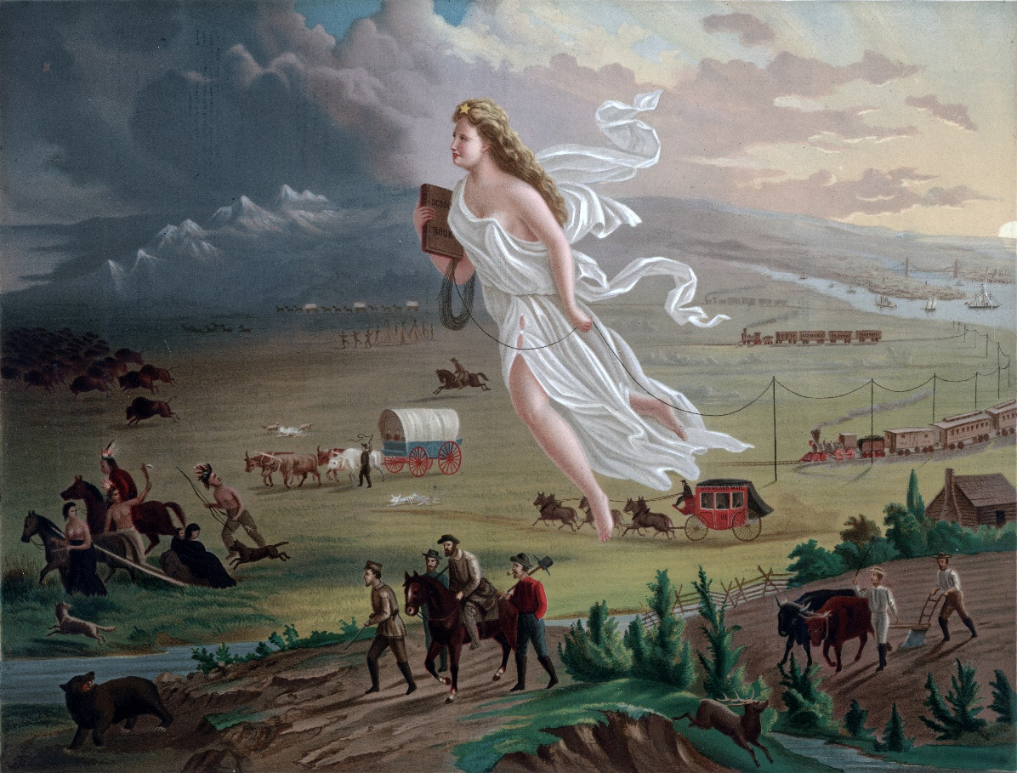
Feel free to comment on what you see and use that understanding to help us all better flesh out this important idea!
Discussion 2: The Market Revolution
Discuss America’s transportation revolution that took place during the first half of the 1800s, including the development of roads, canals, railroads, and steamboats. How did they contribute to the “market revolution?” Elaborate
During the middle of the 19th century, American society changed radically in the North, with the massive increase and expansion of manufacturing, transportation networks, immigration, and urbanization.
So, in order to facilitate the first part of our discussion, I'd like us to focus on (3) pieces of the text and look for evidence that answers the following question: Which of these changes had the biggest impact on Northern society and why?
In order to answer this question and argue your point, please consult the following portions of Chapter 9 in our text:
"The Market Revolution," p. 254
"The Spread of Industrialization," p. 260
"The Changing Urban Landscape," p. 264

